- Exercise 8.1

Frequencies
 | Area 2
A | 19
B | 30
Other | 41
Total | 90
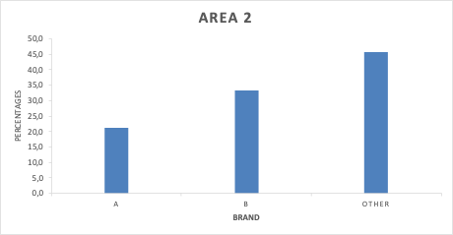
Percentages
 | Area 2
A | 21,1
B | 33,3
Other | 45,6
Total | 100

Interpretation :

The percentage frequency bar chart for Area 2 shows that “Other” brands are the most preferred, accounting for 45.6% of respondents. Brand B is the second most popular choice at 33.3%, while Brand A is the least preferred, with only 21.1%.

Overall, the chart shows a clear ranking of preferences in Area 2, with respondents strongly favouring brands other than A or B. However, compared with Brand A, Brand B attracts a noticeably higher proportion of consumers, suggesting it is more competitive in this demographic.

These results indicate that brand preferences in Area 2 are skewed towards alternative brands, with Brand A being relatively unpopular.

- Exercise 8.2

Frequencies
 | Location A | Location B
Absent | 8 | 20
Sparse | 22 | 14
Abundant | 26 | 10
Total | 56 | 44

Percentages
 | Location A | Location B
Absent | 14,3 | 45,5
Sparse | 39,3 | 31,8
Abundant | 46,4 | 22,7
Total | 100 | 100

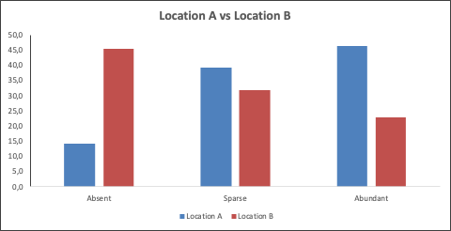

Interpretation :
The clustered percentage bar chart clearly highlights differences in the prevalence of heather species between Location A and Location B.
- Location A is dominated by abundant heather, which accounts for the most significant proportion of observations (around 46%). Sparse heather is also common (about 39%), while absent heather is relatively rare (about 14%). This indicates that Location A generally provides favourable conditions for heather growth.
- Location B, by contrast, shows a much higher proportion of absent heather (about 45%), with fewer sites classified as sparse (about 32%) and even fewer as abundant (about 23%). This suggests that Heather is less well established in Location B.
The chart indicates that heather is significantly more prevalent in Location A than in Location B. Location A supports more abundant and widespread heather growth. In contrast, Location B is characterised by a higher likelihood of heather being absent, possibly reflecting less suitable environmental or ecological conditions.

- Exercise 8.3
Diet A
 |  |  |  |  | Class | Relative
Diet A | n | 50 | UCB | Frequency | Mark | Frequency
 | Mean | 5,3412 | 0 | 1 | -1 | 0,02
 | SD | 2,535603 | 2 | 3 | 1 | 0,06
 |  |  | 4 | 10 | 3 | 0,2
 | Min | -1,715 | 6 | 15 | 5 | 0,3
 | Max | 10,062 | 8 | 15 | 7 | 0,3
 | Range | 11,777 | 10 | 5 | 9 | 0,1
 |  |  | 12 | 1 | 11 | 0,02
 |  |  | Total | 50 | Total | 1

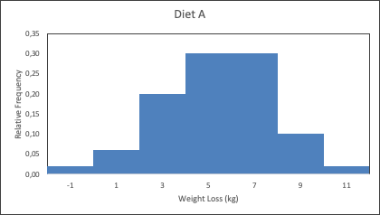

Diet B

 |  |  |  |  | Class | Relative
Diet B | n | 50 | UCB | Frequency | Mark | Frequency
 | Mean | 3,70996 | 0 | 3 | -1 | 0,06
 | SD | 2,769042 | 2 | 10 | 1 | 0,2
 |  |  | 4 | 15 | 3 | 0,3
 | Min | -4,148 | 6 | 11 | 5 | 0,22
 | Max | 10,539 | 8 | 8 | 7 | 0,16
 | Range | 14,687 | 10 | 2 | 9 | 0,04
 |  |  | 12 | 1 | 11 | 0,02
 |  |  | Total | 50 | Total | 1

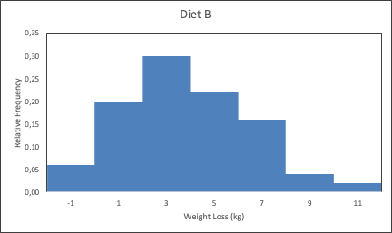

Interpretation:

The histogram for Diet A is unimodal and approximately symmetric, with most observations concentrated in the 4–8 kg range. The centre of the distribution aligns with a mean of about 5.3 kg, and the tails are light, indicating few extreme outcomes. This suggests that Diet A produces consistently moderate weight loss for most participants, with relatively low variability and predictable results.
In contrast, Diet B’s histogram is more dispersed and shifted towards lower weight losses, with many observations between 0 and 4 kg. The mean is lower (about 3.7 kg), and the range is wider, indicating greater variability and more uneven outcomes, including some very low (even negative) changes.

Together, the histograms indicate that Diet A is both more effective and more consistent, whereas Diet B yields minor average losses with greater variability across individuals.

